JAVA NUMBER QUIZ LAB REPORT
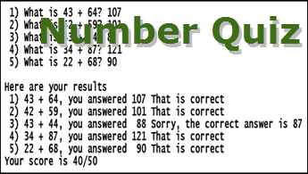
1) Enter your name, student ID, platform (Mac or PC) and date
Name and StudentID: Jibran Akhter - 1073973
Class: CIS084 Java Programming
Platform (Mac or PC): PC
Develop Environment: (NetBeans, Eclipse, JDoodle): onlineGDB
Date: 4/7/2024

OBJECTIVES:
Use arrays in Java with subroutines to build and run a simple numeric quiz.

PROJECT DESCRIPTION:
This programming project is from the exercises at the end of chapter 4 in the textbook, "Introduction to Programming Using Java" by David Eck.

Write a program that administers a basic addition quiz to the user. There should be ten questions. Each question is a simple addition problem such as 17 + 42, where the numbers in the problem are chosen at random (and are not too big) by the program when it first starts executing. The program is to ask the user one question at a time and get the user’s answer before moving to the next question and getting the answer for that question.

After asking the questions and getting the answers, the program prints each question again, with the user’s answer. If the user got the answer right, the program should say so; if not, the program should give the correct answer. At the end, tell the user the score as a percentage of correct answers divided by the number of questions.

The program needs to use three subroutine methods, one to create the quiz, one to administer the quiz, and one to grade the quiz. The program is to use arrays of type int[ ] to hold the first and second number from each question, and the user’s answers.

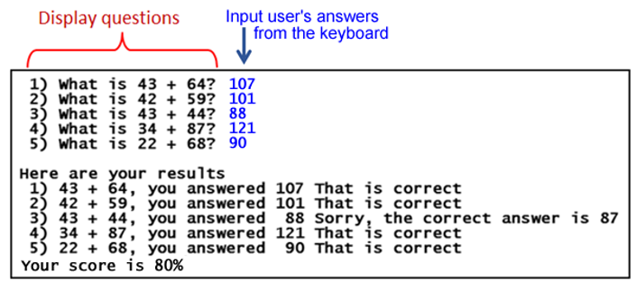

The sample only shows five questions.. Your assignment is to do ten questions.

DISCUSSION:
3) Complete the DISCUSSION section. It does not need to be long, but it needs to be complete.
3a) What did you do to develop the program? ("Followed the Directions" is not a complete description)

To develop the program, I followed the guidelines provided in the project definition. This involved creating a Java program to administer a basic addition quiz to the user. I utilized class-level arrays to store quiz data, implemented methods to generate random numbers for each question, administer the quiz by prompting the user for answers, and grade the quiz based on correctness. Additionally, I ensured that the program adhered to the requirements of using three subroutine methods and a two-dimensional array.

3b) What problems did you have and how did you overcome the problems?

While developing the program, one challenge I encountered was ensuring that the random numbers generated for each question fell within the specified range of 10 to 99. To overcome this, I used the `Random` class in Java and applied the `nextInt()` method with appropriate bounds.

Another issue was handling user input validation, such as ensuring that the user entered integers as answers and preventing the program from crashing if invalid input was provided. To address this, I used exception handling techniques, particularly the `Scanner` class to validate and handle user input.

PROGRAM OUTPUT:
4) Show two screenshots of the program execution. Provide one screenshot where all 10 answers are correct, and a second screenshot that has both correct and incorrect answers.

IMPORTANT: Capture only the portion of the screen that shows the program output. Do not capture the entire screen even though it may also contain the program output. Many times when I zoom in on the output window, the image resolution is so poor that I am not able to read your output. If this happens, I will ask that you resubmit your lab report. You can refer to previous lab assignments on how to do a screen capture.

Place your screenshots here

